**Responding to Children’s Interest: Educating 3, 4, and 5 Year Old Children**

**Farm Project**

Alex Alix, Donna Hickox, Karen Kyle & Patti Verville

Daycare

**General information about the project**

The project we chose was “Farm”. The children who participated in this project were between two and half to six years old. Our daycare offers full time, part time, and casual care so, we have anywhere from five to 13 children participating with the project each day.

**Phase 1: Beginning the Project**

We chose to do our project on the subject of farm because we live in a farming community. Our children are very interested in all things farm related and we have a large number of boys in our group.

When the project started the educators sat down together to make a web of what we knew about the topic. Then we sat down with the children to create a web and find out what they knew about farms/farming and what they wanted to know more about.

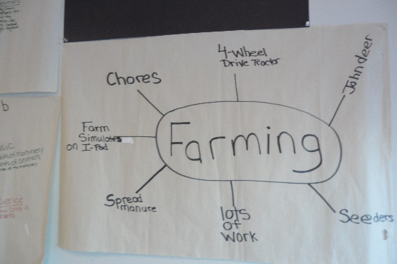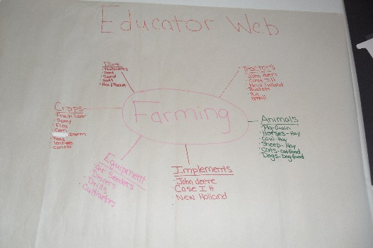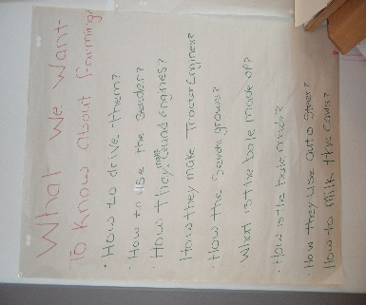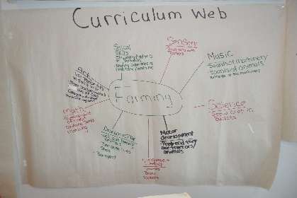

The educators started to come up with ideas of how we could kick start the project. We came together to gather materials and supplies such as books, puzzles, grain, animals, tractors, wheat, etc... We purchased some additional supplies to use within the daycare as well.

**Phase 2: Developing the project**

**Arts/crafts**

Stamps with farm animal designs were purchased to add to our art/craft area.

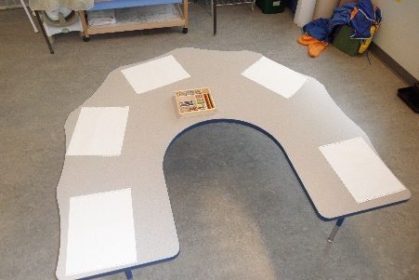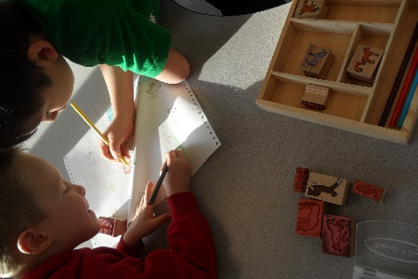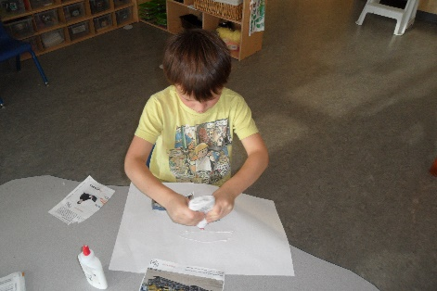

The children created some animals to add to the barn picture that was drawn and hung on the wall.

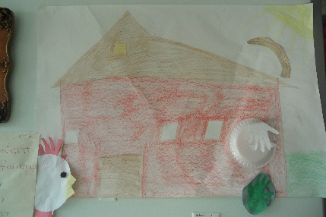

The children created collages of their favorite farm machines.

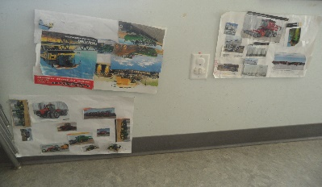

**Science**

The children were able to plant seeds in a clear plastic cup and watch them grow.

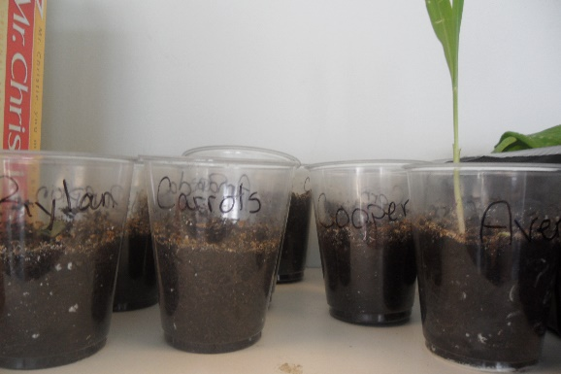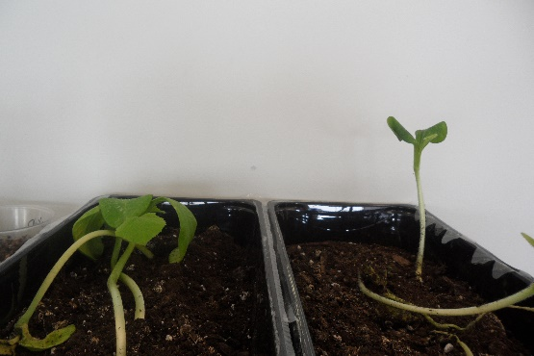

**Dramatic Play**

The children acted out being farm animals. They enjoyed playing games where they were crawling around on their hands and knees making farm animal sounds.

A student brought in a wolf hide to show the children. They learned about predators that people on farms need to be aware of to protect their animals.

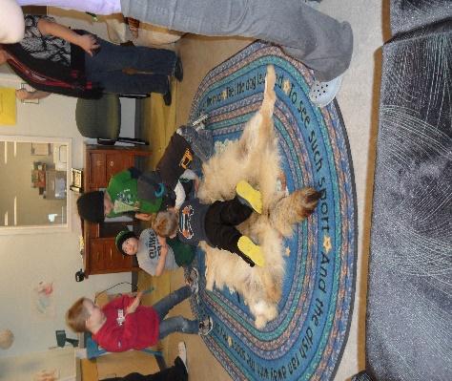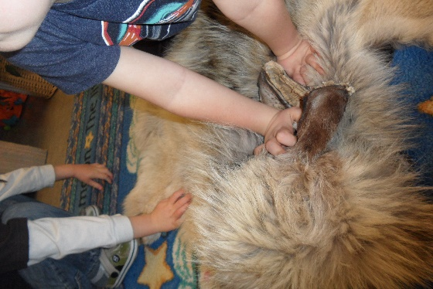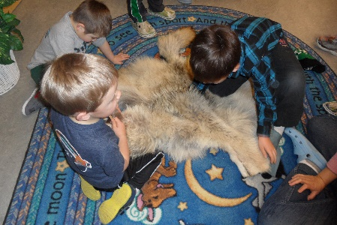

**Gross motor**

A farm center was created in the classroom for the children.

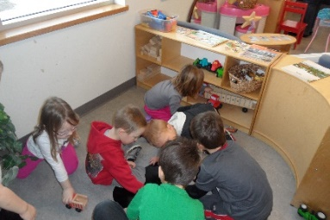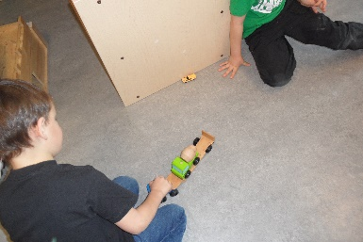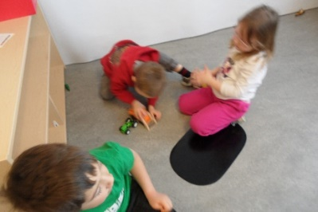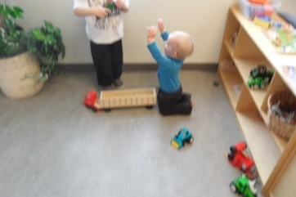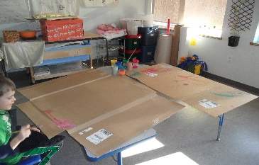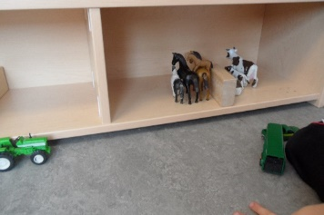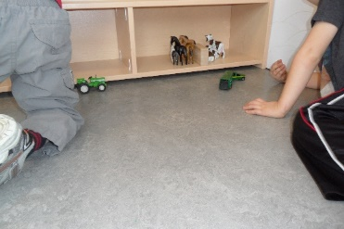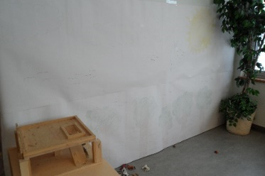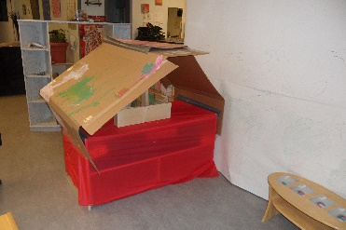

The children created a barn with sticks and connectors.

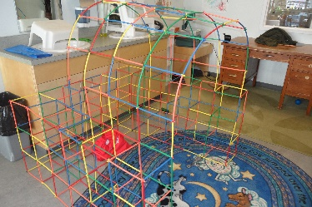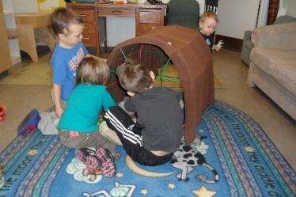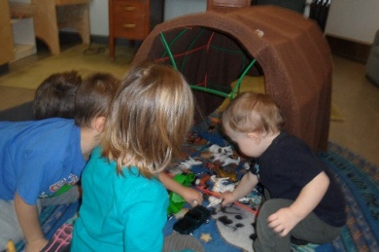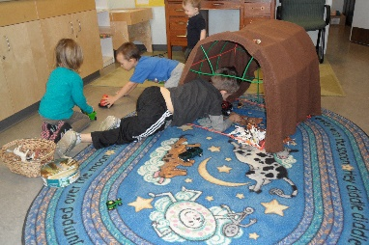

February 7, 2014 10:00-10:30am:

K. was building a structure with straws and connectors. N. came to help.

N. – “Nice barn”

J. comes to see

J. – “Can I help?”

N. – “Can we put the animals in the barn?”

Teacher – “Yes”

N. – “I don’t know where they are?”

J. – “I do!”

Teacher – “J., can you please show N. where they are?”

J. – “Sure, let’s go get some.”

J. – “We brought tractors too. They have those on farms too.”

Teacher puts a blanket over the straws to make a roof.

V. comes to play too

N. – “Cock-a-doodle-doo!” (Picture 1)

J. – “Look at me, a window!” (Picture 2)

N. – “Hey, Can you take a picture of my horse?” (Picture 3)

Teacher – “Sure, can you show it to me?”

Kids continue to play for a while then, move onto different activities.

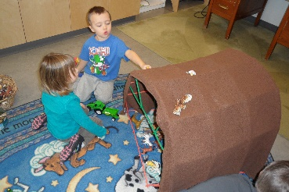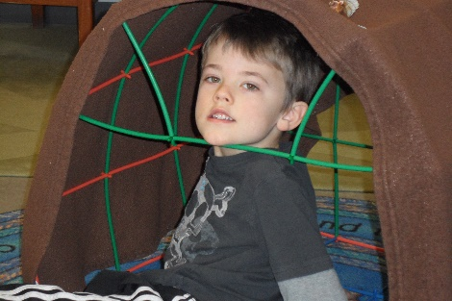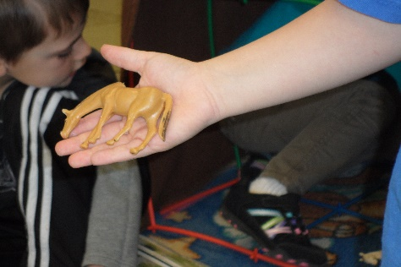

**Language/Literacy**

Tractor and farm books were put out for the children to look through and be read to the children by the educators.

A magnet board was created with pictures and words for the children to match.

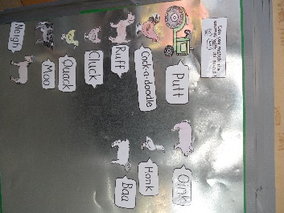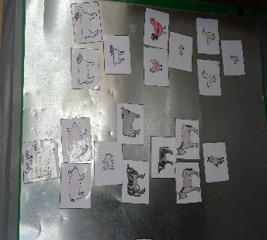

**Sensory**

Buckets were created with seeds, hay, straw, animals, and tractors for the children to play in.

Sand was put in the water table with tractors and other materials for the children.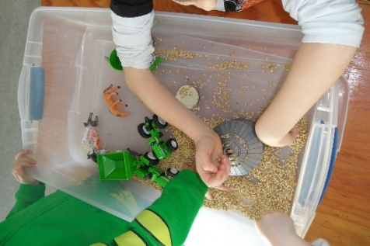 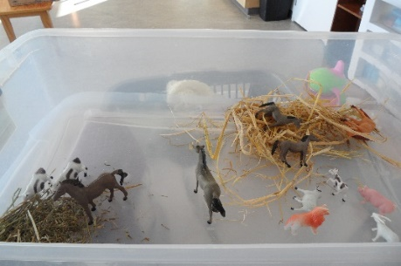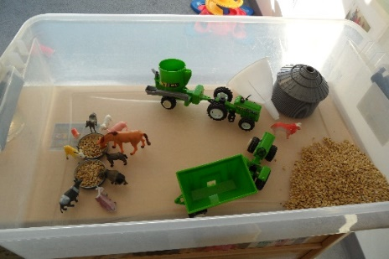 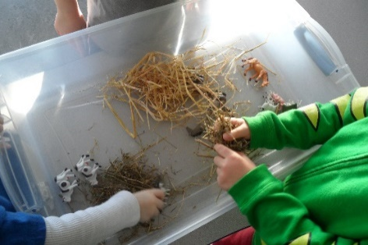

**Phase 3: Concluding the Project**

This project is still ongoing. We plan to take the children on an excursion to a local business. This will show the children where farmers order parts, get oil and filters from. This business also has some grain augers for sale beside the building. The children would be able to investigate these grain augers and find out how they work. We also plan to take a walk to an old barn just outside of our town. We would like to bring clip boards and pencils for the children to create representations of what they see. We are also very fortunate to have two grain elevators on the edge of our town and will be walking with the children to see them as well.

**Teacher Reflection**

We learnt that you must be ready for the children to ask you questions and need to have an answer for them or let them know that we can look it up on the internet together to find out what it is. Some other things that we learnt were large technical words and names of equipment that some of the children already knew. Also, some of the children knew what the equipment did.

The children were very engaged in the project once we brought out our sensory tubs and the different books we had gathered for them to look through. Some of the children took the books, cut out pictures of what they would like on their farm, and made a collage. What also surprised us was the way the children would use the equipment that was put out for them and how their imaginations would flourish by using the toys or how they would take the farm toys and incorporate them into other centres around the daycare.

It was a great topic as our centre has so many farm children. We feel that it was expanding on the knowledge that they already had, it also helped them better understand how things may work or run on a farm. The few girls that we do have in our centre that are in the preschooler group were engaged more with the sensory tubs or the art work. They did join the large group play when they felt comfortable or when they saw the boys needed their help.

The difficult part was trying to have enough objects and materials in place to keep their little minds thinking and exploring. There were some materials that were not available; however, our project is still on going. So, as the season changes we will have a chance to get those materials brought in for the children to investigate and explore.

We feel as though we could have had more observations with the group of children and possibly have had more activities or things for them to explore about farms/farming.

**Alex’s Reflection**

The things that were meaningful to me were how all the children were engaged each in their own way. There never seemed to be two children who were doing the same thing or had the same idea. The children would share ideas with each other and those ideas lead to other new ideas. This encouraged the children to further explore the topic.

**Donna’s Reflection**

I know more about farming than I thought I did; however, there were small things that I was surprised I didn’t know, such as the difference between straw bales and hay bales. I think that the children seemed very comfortable with this project and were quite willing to share their knowledge. It really proved to me how good of a team we are and how valuable these projects are for both the children and the staff.

**Karen’s Reflection**

During the process it was great to see how the children were really into the farming project. They had really great ideas that I wouldn’t have thought about. I’m positive that we picked the right project according to their excitement.

**Patti’s Reflection**

I enjoyed this project because I grew up on a farm and live in this farming community. I am surprised at all the things that we can do with the children to expand their learning.